**VISVESVARAYA TECHNOLOGICAL UNIVERSITY**

**Jnana Sangama, Belgaum-590014**

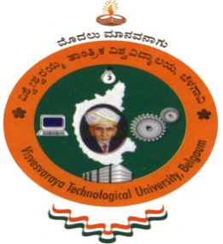

**A Mini Project Report On**

**MULTIPLE-DISEASE-PREDICTOR**

**USING PYTHON**

**Submitted in Partial fulfillment of the Requirements for the VI Semester of the Degree of**

**Bachelor of Engineering**

**In**

**Information Science & Engineering**

**By**

**AKASH KUMAR(1CE21IS002)**

**Under the Guidance of**

**(Prof.R.Mirudhula)**

**Dept. of ISE**



**CITY ENGINEERING COLLEGE**

**Doddakallasandra, Kanakapura Road,**

**Bengaluru-560061**

**CITY ENGINEERING COLLEGE**

**Doddakallasandra, Kanakapura Road, Bengaluru-560061**

**DEPARTMENT OF INFORMATION SCIENCE AND ENGINEERING**



**CERTIFICATE**

Certified that the Mini Project work entitled **“Multiple-Disease-Predictor using python”** has been carried out by **Akash Kumar(1CE21IS002)** a bonafide student of City Engineering College in partial fulfillment for the award of **Bachelor of Engineering** in **Information Science and Engineering** of the Visveswaraya Technological University, Belgaum during the year **2023-2024**. It is certified that all corrections/suggestions indicated for Internal Assessment have been incorporated in the Report deposited in the departmental library. The Mini Project has been completed and it satisfies the academic requirements as per VTU norms with respect of Mini Project work prescribed for the said Degree.

Prof.R.Mirudhula Dr. B. Sakthivel Dr. S. Karunakara

Mini Project Coordinator HOD, Dept. of ISE Principal, CEC

External Viva

Name of the examiners                                                                           Signature with date

1.

2.